PARKING CARD PROCEDURE

- to ask for the parking card you have to fill in and print the Parking card request form available here below;

- you have to send this form to facilities@imtlucca.it;

- to pay the total amount and collect/renew the parking card you have to go to “Ufficio Tessere e Abbonamenti”, Viale G.Carducci 343, 55100 LU (Opening hours: Monday-Saturday from 08:30 a.m. to 13.30 p.m. Tel 0583 495323 email: ufficiotessere@metrosrl.it).

Please note that the request must be made by the 24th of any month. In the event of the School offices being closed on the mentioned deadline, please remember to complete the procedure before the last working day.

There are two parking areas available:

Option A – The parking area is located just outside Porta Elisa (as showed in the map below in yellow)

The cost of the parking card is:

- € 20,00 1 month
- € 50,00 3 months
- € 90,00 6 months
- € 170,00 1 year

Option B – This parking area (Parcheggio Mazzini) is located beside San Francesco Campus and is an underground parking. The monthly cost for a parking card is € 20,00 per month.

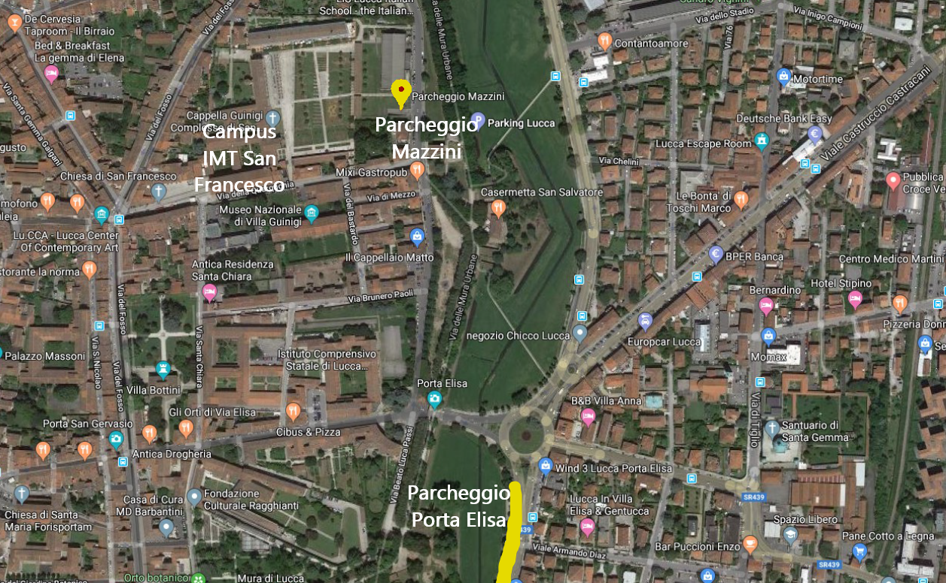

REQUEST
To be sent to facilities@imtlucca.it by the 24th of any month.
If the School offices are closed on the mentioned deadline, please remember to complete the procedure before the last working day.

Name and Surname: ______________

Option:

 | A– Porta Elisa |  | B – Mazzini

Role:

 | IMT Staff |  | PhD Student
 | Professor |  | Other
 | Researcher

Select the month/s (we consider the current year):

 | January 20XX |  | July 20XX
 | February 20XX |  | August 20XX
 | March 20XX |  | September 20XX
 | April 20XX |  | October 20XX
 | May 20XX |  | November 20XX

 | June 20XX |  | December 20XX

Number of months: | _
Total cost: | _

